Question 10
Using MyCompress (Question 1) to filter a test file of 11.7 MB.
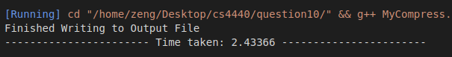

Using ParFork (Question 5) to filter a test file of 11.7 MB

Using ParThread (Question 9) to filter a test file of 11.7 MB

